**Media Control using Hand Gesture Moments**

**Submitted by: -**

**KARTIK M 2SD19IS402  
PRASHANT S N 2SD18IS031  
SARDAR PARAMJEET SINGH 2SD18IS044  
SUSHMA S 2SD18IS056**

**Under the guidance of**

**Prof. Jagadeesh Pujari**

**8th Semester B. E. Academic Year 2021-22**

**SHRI DHARMASTHALA MANJUNATHESHWARA COLLEGE OF ENGINEERING & TECHNOLOGY**

**(Autonomous Institution under Visvesvaraya Technological University, Belagavi-590018)**

**Dhavalagiri, Dharwad, Karnataka, India – 580002**

**SDM COLLEGE OF ENGINEERING AND TECHNOLOGY, DHARWAD - 580002**

** (An autonomous Institution affiliated to VTU, Belagavi – 590018)**

**Department of Information Science and Engineering**

**CERTIFICATE**

*Certified that the project work entitled* ***“******Media Control using Hand Gesture Moments”*** *is an original work carried out by* ***Mr. KARTIK M* *[2SD19IS402], Mr. PRASHANT S N [2SD18IS031], Mr. SARDAR PARAMJEET SINGH*  *[2SD18IS044] and Mr* *SUSHMA S [2SD18IS056]*** *in partial fulfilment for the award of degree of* ***Bachelor of Engineering*** *in* ***Information Science and Engineering*** *of* ***S.D.M. College of Engineering & Technology under Visvesvaraya Technological University, Belagavi*** *during the year* ***2021-22****. The project report has been approved as it satisfies the academic requirements in respect of Project work prescribed for the Bachelor of Engineering Degree.*

______________ ____________________ _______________

**Dr. J. D. Pujari Prof. Varsha S. Jadhav Dr. K. Gopinath**

**Project Guide & Project coordinator Principal**

**HOD ISE**

|  |  |  |
| --- | --- | --- |
| **Sl. no** | **Name of the Examiner** | **Signature of the Examiner** |
| **1.** |  |  |
| **2.** |  |  |
| **3.** |  |  |

**TABLE OF CONTENTS**

PREFACE i

ACKNOWLEDGEMENT ii

ABSTRACT iii

CHAPTER 1:INTRODUCTION 1

1.1 Introduction 2

1.2 Problem Statement 2

1.3 Objectives 2

1.4 Methodology 3

CHAPTER 2:LITERATURE SURVEY 4

2.1 Need for Research 5

2.2 Existing System 5

2.3 Proposed System 6

CHAPTER 3:TECHNOLOGY USED 8

CHAPTER 4:SOFTWARE REQUIREMENT SPECIFICATION 14

4.1 Product Perspective 15

4.2 Constraints 16

4.3 Functions 16

4.4 Performance Requirements 16

4.5 Software System Attributes 16

4.6 Software and Hardware Requirements 17

CHAPTER 5:DESIGN PHASE 18

5.1 ER Diagram 19

5.2 Data Flow Diagram 20

5.3 Architectural Design 21

5.4 Client Server Model 22

5.5 UML Design 22

5.6 Advanced Interaction Mode 24

5.7 Swimlane Activity Model 25

5.8 User Interface Design 26

CHAPTER 6:IMPLEMENTATION PHASE 27

6.1 Module – 1 : The Customer Module 28

6.2 Module – 2 : The Bank Module 28

6.3 Module – 3 : The KYC Regulator Module 28

6.4 Pseudo Code/Source Code Of Each Implemented Module 29

CHAPTER 7:TESTING PHASE 33

7.1 Software Testing 34

7.2 Types Of Tests Carried Out 34

7.3 System Setup 35

7.4 Functional Testing 35

7.5 Non-Functional Testing: 36

7.6 Test Cases 37

CHAPTER 8:RESULT AND DISCUSSION 40

CHAPTER 9:APPLICATION 49

CHAPTER 10:CONCLUSION 51

CHAPTER 11:FUTURE SCOPE 53

REFERENCES 55

PAPER PUBLISHED 57

CERTIFICATES 62

# LIST OF FIGURES

FIG 2.2.1 TRADITIONAL KYC SYSTEM 5

FIG 2.3.1 PROPOSED SYSTEM OF KYC 6

FIG 3.1.1.1 REMIX ENVIRONMENT 9

FIG 3.1.1.2 REMIX LAYOUT 9

FIG 3.1.2.1 GANACHE WORKSPACE INDEX 10

FIG 3.1.2.2 GANACHE - VISUAL MNEMONIC & ACCOUNT INFO 10

FIG 3.1.8 VISUAL STUDIO CODE EDITOR 13

FIG 5.1 ER DIAGRAM 19

FIG 5.2 DATA FLOW DIAGRAM 20

FIG 5.3 ARCHITECTURAL DESIGN 21

FIG 5.5.1 ADVANCED CLASS DESIGN 22

FIG 5.5.2 ADVANCED STATE DESIGN FOR KYC REGULATOR 23

FIG. 5.6.1 USER CASE MODEL 24

FIG. 5.6.2 SEQUENCE MODEL 24

FIG 5.7 SWIMLANE ACTIVITY MODEL 25

FIG 5.8 UI REPRESENTATION OF E-KYC VERIFIER USING BLOCKCHAIN 26

FIG 6.4.1.1 CUSTOMER PAGE – I 29

FIG 6.4.1.2 CUSTOMER PAGE – II 29

FIG 6.4.2 THE CONTRACT DETAILS 30

FIG 6.4.3.1 THE INDEX PAGE – I 30

FIG 6.4.3.2 THE INDEX PAGE - II 31

FIG 6.4.3.3 THE INDEX PAGE - III 31

FIG 6.4.4 THE KYC SMART CONTRACT 32

FIG 8.1.1.1 MAIN PAGE – I 41

FIG 8.1.1.2 THE MAIN PAGE - II 41

FIG 8.1.1.3 THE MAIN PAGE - III 42

FIG 8.1..1.4 THE MAIN PAGE – IV 42

FIG 8.1.2.1 THE BANK LOGIN PAGE 43

FIG 8.1.2.2 ADDING PERSONAL DETAILS PROVIDED BY THE CUSTOMER TO BANK 43

FIG 8.1.3.1 CUSTOMER SIGNUP 44

FIG 8.1.3.2 CUSTOMER REGISTRATION 44

FIG 8.1.3.3 CUSTOMER LOGIN 45

FIG 8.1.4.1 ACCESS FROM BANK 45

FIG 8.1.4.2 REQUEST SENT TO CUSTOMER FOR AUTHENTICATION 46

FIG 8.1.4.3 CONFIRMATION FROM CUSTOMER 46

FIG 8.1.4.4 CUSTOMER DETAILS DISPLAYED AT BANK’S END 46

FIG 8.1.5.1 CUSTOMER DETAILS MODIFICATION 47

FIG 8.1.5.2 SUCCESSFUL MODIFICATION AND UPDATED DETAILS 47

## PREFACE

Know Your Customer (KYC) process is a mandatory verification step for availing any service from any service provider. The KYC process is done before getting a job, a broadband connection, a new sim card, applying for a license, a PAN card, opening an account in a bank, and many other such services. The customer submits a certain set of documents to the service provider which contains information that is required to complete the KYC process.

This becomes a redundant process when the customer wishes to avail the same services from a different service provider because the same set of documents are used to verify the customer.

We propose and program a blockchain-based system that reduces and shares out among the financial institutions (FIs) that work with a customer the costs of the KYC process and also makes it possible for FIs to dynamically update information related to customers and disseminates this information among participating FIs Our system increases the levels of security and regulatory compliance in the KYC process and significantly reduces the cost of that process for all parties involved.

## ACKNOWLEDGEMENT

We have been bestowed the privilege of expressing our gratitude to everyone who helped us in completing the project.

We sincerely thank **Dr. Jagadeesh D. Pujari**, project team guide, Department of Information Science and Engineering, SDMCET, for guiding and helping us throughout in carrying out the project.

We thank **Prof. Varsha S. Jadhav**, project coordinator, Department of Information Science and Engineering, SDMCET, for coordinating with us throughout in carrying out the project.

We also thank **Dr. Jagadeesh D. Pujari**, Head of the Department, Department of Information Science Engineering, SDMCET, for providing us a proper platform to carry out the project.

We also thank **Dr. K. Gopinath**, Principal, SDMCET, for providing us a proper platform to carry out the project. We thank the supporting staff and all who have directly and indirectly assisted us in the project work.

Lastly, we would also like to thank our friends and families for providing constant comforting support and encouragement all the way from the beginning to the end of our project.

## ABSTRACT

A hand gesture recognition system provides a natural, innovative and modern way of non - verbal communication. It has a wide area of application in human computer interaction and sign language. The intention of this implementation is to discuss an approach of hand gesture recognition based on detection of some shape based features. The setup consists of a single camera to capture the gesture formed by the user and take this as input to the system. A primary goal of gesture recognition is to create a system which can identify specific human gestures and use them to convey information for device control and by implementing real time gestures recognition a user can control a computer by doing a specific gesture in front of a video camera linked to a computer. In this project we will develop a hand gesture volume control system with the help of OpenCV module. Here the system can be operated using hand gestures without using keyboard and mouse.

# CHAPTER 1:

# INTRODUCTION

## 1.1 INTRODUCTION

Everyone is dependent to perform most of their tasks using computers. The major input devices are keyboard and mouse. But there are a wide range of health problems that affects many people, caused by the constant and continuous work with the computer. Direct use of hands as an input device is an attractive method for Human Computer Interaction Since hand gestures are completely natural form for communication so it does not adversely affect the health of the operator as in case of excessive use of keyboard and mouse. The User interface has a good understanding of human hand gestures. By using the gesture, Feelings and thoughts can also be expressed. Users generally use hand gestures to express their feelings and notifications of their thoughts. Hand gesture and hand posture are related to the human hands in hand gesture recognition. In this paper we are going to present an application which uses dynamic hand gestures as input to control the windows media player. We have considered single handed gestures and their directional motion defines a gesture for the application. In this application image acquisition is done using a Webcam. Some functions in windows media players are used more frequently and thus applying controls windows media player for those functions using predefined gestures. Fig. 1 shows the defined gestures according to the windows player control function.

## 1.2 Problem Statement

“To develop a KYC (Know Your Customer) process using blockchain technology which overcomes the difficulties and redundant procedures used in conventional KYC process adopted by various institutions.”

## 1.3 Objectives

* To develop a KYC Blockchain system that safeguards transparency (by storing information in such a way that it cannot be altered without recording the changes made).
* To develop a system that enables immutability, which in turn, allows financial institutions to validate the trustworthiness of data present in the DLT platform.
* To deploy a KYC system that must overcome the challenges with the existing manual KYC Verification System.

## 1.4 Methodology

* Gesture recognition helps computers to understand human body language. This helps to build a more potent link between humans and machines, rather than just the basic text user interfaces or graphical user interfaces (GUIs).
* In this project for gesture recognition, the human body's motions are read by computer camera. The computer then makes use of this data as input to handle applications.
* The objective of this project is to develop an interface which will capture human hand gesture dynamically and will control the volume level. For this, Deep Learning techniques such as Yolo model, Inception Net model+LSTM, 3-D CNN+LSTM and Time Distributed CNN+LSTM have been studied to compare the results of hand detection. The results of Yolo model outperform the other three models.
* The models were trained using Kaggle and 20% of the videos available in 20 billion jester data set. After the hand detection in captured frames, the next step is to control the system volume depending on direction of hand movement.
* The hand movement direction is determined by generating and locating the bounding box on the detected hand.

# CHAPTER 2:

# LITERATURE SURVEY

## 2.1 Need for Research

With the current rate of growth of the banking sector, such an approach really has the ability to bring about big improvement and shared gain to all of concerned stakeholder. We can include this research to payment wallet where the framework can be used to conduct KYC process for the customer.

## 2.2 Existing System

KYC, as defined by the Reserve Bank of India (2016) is a process by which banks obtain information about the identity and address of the customers. KYC means “Know Your Customer”. KYC processes are generally repetitive, inconsistent, and duplicated, leading to high administrative overheads and costs. The process also includes risk management with regard to on boarding new customers, the Monitoring of transactions, and specific customer policies for banks. The process is costly for financial institutions and may expose them to large fines if it is not conducted in accordance with the existing regulations.

Figure 2.2.1 represents the current KYC process in which each customer has to register the documents three times there by increasing the cost to three times which could have been performed in single time.

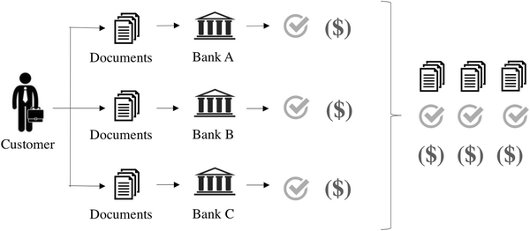

#### Fig 2.2.1 Traditional KYC System

## 2.3 Proposed System

In a new model that uses Distributed Ledger Technology (DLT) to conduct the fundamental KYC verification process once for a specific customer, is proposed. This will decrement the expense of conducting the KYC process by the bank and enhance the bank and customer relationship. The customer has complete ownership of the data and only with consent; the data is shared with other financial institutions. The proposed system comprises of smart contract and DLT. Firstly, a trusted third party such as a regulator is used to maintain and manage the service providers such as banks, network providers. Secondly, a presumption that all the similar service providers agree to the average cost of the KYC process per category of customers.

Lastly, the customers are categorized based on the effort required by the service provider to do their KYC process. The system also considers the effort required to update the KYC process and the cost inferred for it for a customer. The proposed model can be divided into three modules and two smart contracts. The modules are as follows the customers, the KYC regulator, and the banks. The first smart contract adds customers to the network and initializes a blockchain for each document submitted. The second smart contract updates the stake of the banks in the customer value as blocks are added into the blockchain.

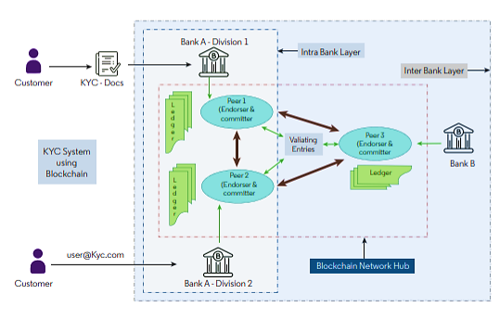

#### Fig 2.3.1 Proposed System of KYC

A customer approaches the KYC Regulator, registers to the network, and submits his or her documents. The KYC Regulator verifies the documents and stores them in the local database and initializes a blockchain for each document. Customer value is added when the blockchain gets initialized. When a customer approaches a bank to open an account, the KYC documents must be submitted. The bank which is already registered to the network, request for a customer’s specific document to the KYC Regulator. The KYC Regulator asks the customer whether the request for the document can be accepted or not. The customer sends the reply to the KYC regulator and based on the customer’s reply the request is either accepted or rejected.

The KYC regulator updates the bank’s request, and if it is accepted then the document is sent to the bank. Once the documents are sent to the customer, a block is mined into the blockchain of that document. The customer value is updated once the block is added. For all the blocks created for the customer is accounted as transactions by the KYC Regulator.

A stake is provided for the banks working with the customer in the customer value. This stake gets updated as transactions keep occurring for that customer. The same process is repeated every time a new request is received by the KYC Regulator. When a customer joins the network by providing the documents, a blockchain is created for each document provided. A cost, c is assigned to the customer this is known as the initial cost, i. Each time a block is mined into a customer’s blockchain, the cost of the incremented by a constant cost, say, u. The number of times a customer’s document is accessed by various banks is n. The value of n is a dynamic value and keeps getting updated every time a transaction occurs.

# CHAPTER 3:

# TECHNOLOGY USED

## 3.1 TECHNOLOGIES USED

### 3.1.1 REMIX IDE.

Remix IDE is an open-source web and desktop application. It fosters a fast development cycle and has a rich set of plugins with intuitive GUIs. Remix is used for the entire journey of contract development as well as act as a playground for learning and teaching Ethereum.

Remix IDE is a powerful open-source tool that helps you write Solidity contracts straight from the browser.

It is written in JavaScript and supports both usage in the browser, but run locally and in a desktop version.

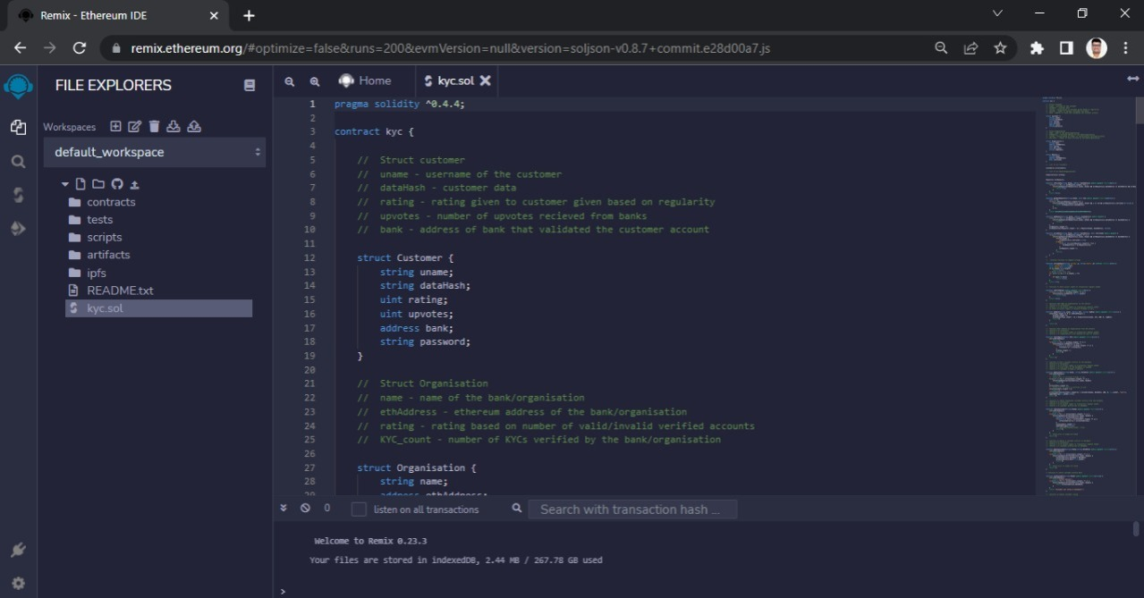 Remix IDE has modules for testing, debugging and deploying of smart contracts and much more.

#### Fig 3.1.1.1 REMIX ENVIRONMENT

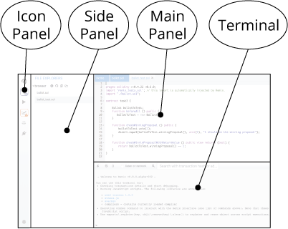**REMIX IDE – Layout**

#### Fig 3.1.1.2 REMIX layout

**The REMIX Layout - Panels**

**Icon Panel** - click to change which plugin appears in the Side Panel.

**Side Panel** - Most but not all plugins will have their GUI here.

**Main Panel** - In the old layout this was just for editing files. In the tabs can be plugins or files for the IDE to compile.

**Terminal** - where you will see the results of your interactions with the GUI’s. Also, you can run scripts here.

### 3.1.2 GANACHE

Ganache is a personal blockchain for rapid Ethereum and Corda distributed application development. We can use Ganache across the entire development cycle; enabling us to develop, deploy, and test our dApps in a safe and deterministic environment.

Ganache comes in two flavours: a UI and CLI. Ganache UI is a desktop application supporting both Ethereum and Corda technology. The command-line tool, ganache-cli (formerly known as the TestRPC), is available for Ethereum development.

**GANACHE WORKSPACE**

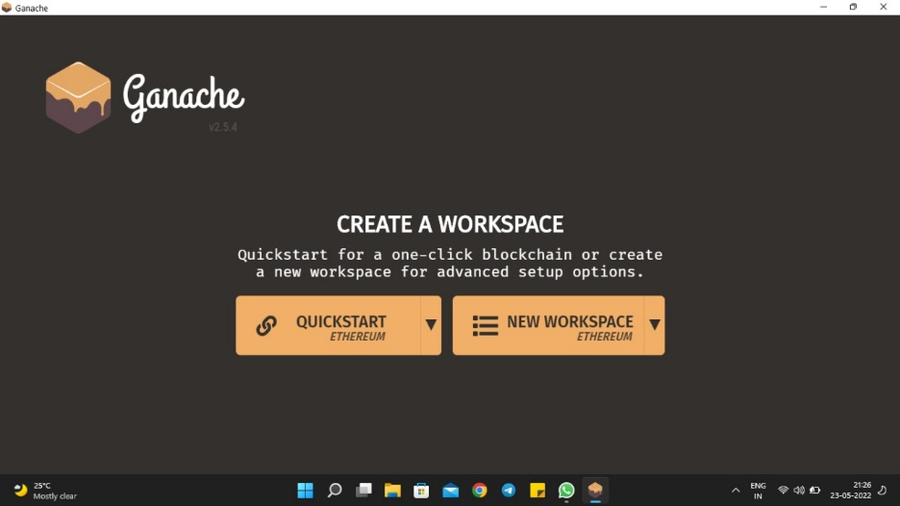

#### Fig 3.1.2.1 GANACHE WORKSPACE INDEX

#### Fig 3.1.2.2 GANACHE - VISUAL MNEMONIC & ACCOUNT INFO

The console in the above screenshot shows user accounts with balance of 99.97 and 100 ETH (Ether - a currency for transaction on Ethereum platform). It also shows a transaction count of zero for each account. As few users have not performed any transactions so far, this count is obviously zero.

### 3.1.3 NODE.JS

Node.js is a platform built on Chrome's JavaScript runtime for easily building fast and scalable network applications.

Node.js uses an event-driven, non-blocking I/O model that makes it lightweight and efficient, perfect for data-intensive real-time applications that run across distributed devices. Node.js is an open source, cross-platform runtime environment for developing server-side and networking applications.

Node.js applications are written in JavaScript, and can be run within the Node.js runtime on OS X, Microsoft Windows, and Linux. Node.js also provides a rich library of various JavaScript modules which simplifies the development of web applications using Node.js to a great extent.

Node.js = Runtime Environment + JavaScript Library

**Following are some of the important features that make Node.js the first choice of software architects.**

* Asynchronous and Event Driven
* Very Fast
* Single Threaded but Highly Scalable
* No Buffering
* License

### 3.1.4 NPM

* **npm** is the package manager for the Node JavaScript platform.
* It puts modules in place so that node can find them, and manages dependency conflicts intelligently.
* It is extremely configurable to support a wide variety of use cases. Most commonly, it is used to publish, discover, install, and develop node programs.
* **npm** is the world's largest **Software Registry**.
* The registry contains over 800,000 **code packages**.
* **Open-source** developers use **npm** to **share** software.
* Many organizations also use npm to manage private development.
* **npm** is installed with **Node.js**
* This means that you have to install **Node.js** to get npm installed on your computer.
* The name **npm** (Node Package Manager) stems from when npm first was created as a package manager for Node.js.
* All **npm** packages are defined in files called **package.json**.
* The content of **package.json** must be written in **JSON**.
* At least two fields must be present in the definition file: **name** and **version**.

### 3.1.5 SOLIDITY

Solidity is an object-oriented, high-level language for implementing smart contracts. Smart contracts are programs which govern the behaviour of accounts within the Ethereum state.

Solidity is a curly-bracket language designed to target the Ethereum Virtual Machine (EVM). It is influenced by C++, Python and JavaScript.

Solidity is statically typed, supports inheritance, libraries and complex user-defined types among other features.

With Solidity we can create contracts for uses such as voting, crowdfunding, blind auctions, and multi-signature wallets. When deploying contracts, we should use the latest released version of Solidity. Apart from exceptional cases, only the latest version receives security fixes. Furthermore, breaking changes as well as new features are introduced regularly. We currently use a 0.y.z version number to indicate this fast pace of change.

### 3.1.6 WEB3.JS

web3.js is a collection of libraries which allow you to interact with a local or remote Ethereum node, using a HTTP or IPC connection.

The web3.js library is a collection of modules which contain specific functionality for the ethereum ecosystem.

* The **web3-eth** is for the ethereum blockchain and smart contracts
* The **web3-shh** is for the whisper protocol to communicate p2p and broadcast
* The **web3-bzz** is for the swarm protocol, the decentralized file storage
* The **web3-utils** contains useful helper functions for dApp developers.
* Adding web3.js: ***npm: npm install web3***

### 3.1.7 HTML, CSS, JAVASCRIPT

* HTML provides the *basic structure* of sites, which is enhanced and modified by other technologies like CSS and JavaScript.
* CSS is used to control *presentation, formatting, and layout*.
* JavaScript is used to control the *behaviour* of different elements.

### 3.1.8 VISUAL STUDIO CODE (VS CODE)

Visual Studio Code, also commonly referred to as VS Code, is a source-code editor made by Microsoft for Windows, Linux and macOS.

Features include support for debugging, syntax highlighting, intelligent code completion, snippets, code refactoring, and embedded Git.

Visual Studio Code is a lightweight but powerful source code editor which runs on your desktop and is available for Windows, macOS and Linux.

It comes with built-in support for JavaScript, TypeScript and Node.js and has a rich ecosystem of extensions for other languages (such as C++, C#, Java, Python, PHP, Go) and runtimes (such as .NET and Unity).

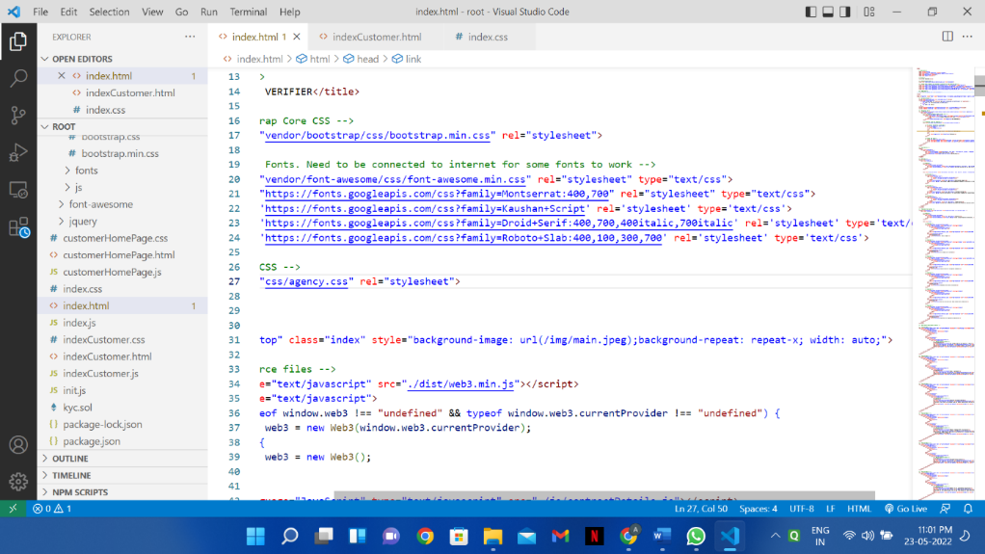

#### Fig 3.1.8 Visual Studio Code Editor

### 3.1.9 PINATA API

Building the largest pinning service on IPFS, Pinata gives users the ability to upload, manage, and share their content whenever, wherever and, with whomever they want.

Pinata is pleased to offer support for the IPFS Pinning Services API Spec. The Pinning Services API spec is a standardized specification for developers building on top of IPFS that allows an application to integrate a pinning service without needing to learn that pinning service's unique API.

# CHAPTER 4:

# SOFTWARE REQUIREMENT SPECIFICATION

## 4.1 Product Perspective

An institution, a bank, for example, sends a request to the blockchain platform to access your identity data.

In this new architecture, data access would be solely based on user consent. To grant consent, a user only has to log in, probably through a One Time Password (OTP) and allocate a private key to the data. Although the data can now be accessed by a third party (the bank in this instance), ownership of the data remains with the user.

The concept of the Blockchain-based KYC platform is already being implemented by IT giants like IBM. The Shared Corporate Know Your Customer (KYC) project assures an efficient, secure and decentralized mechanism to validate, collect, store, refresh and share KYC information for customers.

### 4.1.1 System Interfaces

In this phase a logical system is build which fulfils the given requirements. Design phase of software development deals with transforming client’s requirement into a logically working system. Normally, design is performed in the following two steps:

**Primary design phase**: In this phase the application is designed at block level. The blocks are created on the basis of analysis done in the problem identification phase. Different blocks are created for different function emphasis Is put on the minimizing the information flow between blocks. Thus, all activities are kept in one block.

**Secondary design phase**: In the secondary phases detailed design of every block is performed. The general task involved in the design process are as following

• Design various blocks for overall system processes.

• Design smaller, compact and workable modules in each block.

• Design various database structures

• Specify details of programs to achieve desired functionality.

• Design the form of inputs and outputs of the application.

• Perform documentation of the design.

• Application reviews.

### 4.1.2 User Interfaces

**KYC System:** KYC Data is fed into this system. The user has to upload necessary documents into this system to get verified.

**Administrator:** After the successful submission of the documents in Blockchain KYC system, the administrator in this context is the regulatory body verifies the authenticity of the submitted KYC documents. In this interface the documents uploaded by the customer are verified.

**Bank Portal:** In this interface the Bank gets necessary information of the customer. Details and the authenticity of the customer is verified by the administrator and the verification is completed by the bank.

### 4.1.3 Communications Interfaces

The project can be deployed in any of the Computing systems like Desktops, Laptops, etc. except for handheld devices.

## 4.2 Constraints

### 4.2.1 Memory Constraints

The above specified software’s would require:

RAM: 8GB

Hard Disk/SSD: 250 GB

## 4.3 Functions

The e-KYC verifier shall contain:

* A platform to upload the KYC documents.
* An acknowledgment after documents upload.
* A unique assigned for the Customer.
* Authentication system whenever a bank requests the verification of documents.

## 4.4 Performance Requirements

* The documents need to be secure on the Decentralized system.
* The documents uploaded need to be encrypted for security reasons
* At least 10,000 users must be supported initially

## 4.5 Software System Attributes

### 4.5.1 Security

* ***Customer Identification:*** The application needs customers to recognize himself/herself. The application has to verify the user once registered and subsequently check the login credential whenever the user tries to login.
* ***Login ID:*** Any users who make use of the system need to possess a Login ID and password.
* ***Modifications:*** Any modifications like insert, delete, update, etc. for the database can be synchronized quickly and executed only by the administrator.

### 4.5.2 Availability

The decentralized system needs to be active for most of the time except for that of maintenance time.

### 4.5.3 Maintainability

The system needs very less maintenance. As the system is decentralized, even if a single node fails, there are other machines which carry out the function smoothly.

### 4.3.4 Portability

The application is available and portable on computing platform.

## 4.6 Software and Hardware Requirements

### 4.6.1 Hardware Requirements

***PROCESSOR***: Core i3 Processor Or higher configurations

***RAM***: 8GB or higher

***OPERATING SYSTEM***: Windows 7 Or Higher.

### 4.6.2 Software Requirements

|  |  |  |
| --- | --- | --- |
| **Name** | **Version** | **Source** |
| 1. Solidity | V0.8.11 | https://soliditylang.org**/** |
| 1. Remix IDE | V0.10.3 | https://remix-project.org/ |
| 1. Python | V3.9 | https://www.python.org/downloads |
| 1. Ganache | V7 | https://trufflesuite.com/ganache/ |
| 1. Metamask | V10.8.1 | https://metamask.io/download/ |
| 1. Pinata API. | V1.0.0 | https://docs.pinata.cloud/ |

**Table 4.6.2 Software Interfaces**

# CHAPTER 5:

# DESIGN PHASE

## 5.1 ER DIAGRAM

ER Diagram stands for Entity Relationship Diagram, also known as ERD is a diagram that displays the relationship of entity sets stored in a database. In other words, ER diagrams help to explain the logical structure of databases. ER diagrams are created based on three basic concepts: entities, attributes and relationships.ER Diagrams contain different symbols that use rectangles to represent entities, ovals to define attributes and diamond shapes to represent relationships.

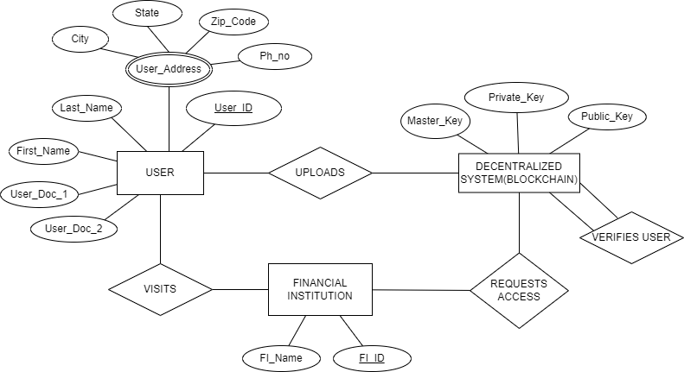

#### Fig 5.1 ER Diagram

## 5.2 DATA FLOW DIAGRAM

Data Flow Diagrams are used to graphically represent the flow of data in a business information system. DFD describes the processes that are involved in a system to transfer data from the input to the file storage and reports generation. Data flow diagrams can be divided into logical and physical. The logical data flow diagram describes flow of data through a system to perform certain functionality of a business. The physical data flow diagram describes the implementation of the logical data flow.

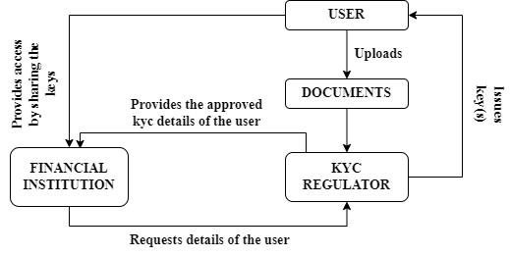

#### Fig 5.2 Data Flow Diagram

## 5.3 ARCHITECTURAL DESIGN

Architectural design is a process for identifying the sub-systems making up a system and the framework for sub-system control and communication. The output of this design process is a description of the software architecture. Architectural design is an early stage of the system design process. It represents the link between specification and design processes and is often carried out in parallel with some specification activities. It involves identifying major system components and their communications.

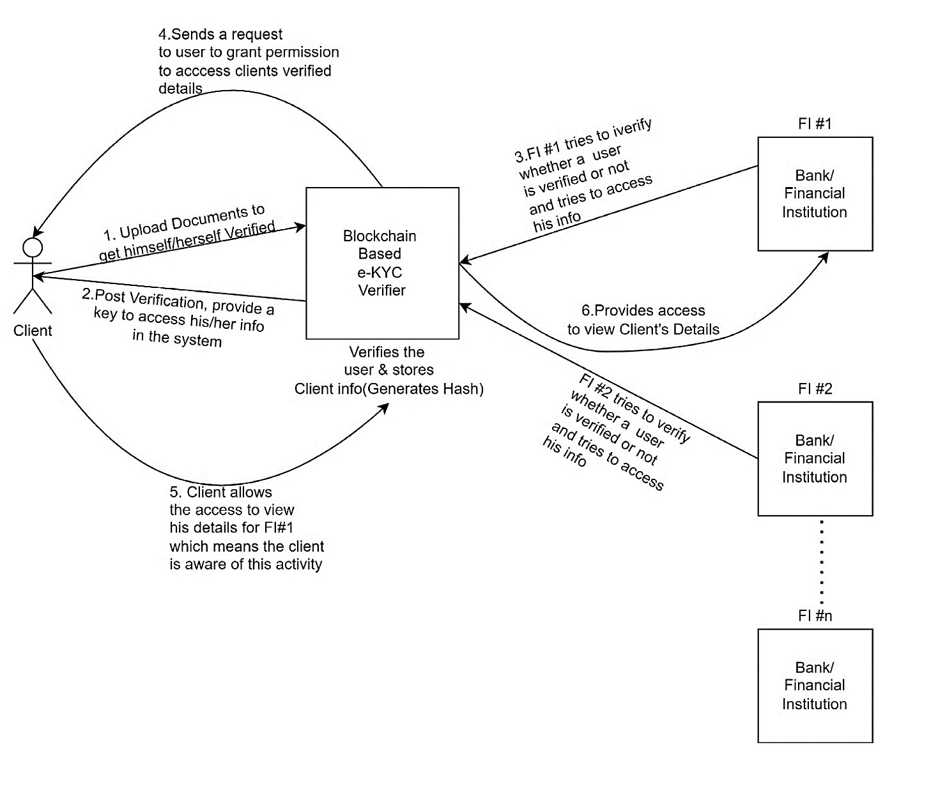

#### Fig 5.3 Architectural Design

## 5.4 CLIENT SERVER MODEL

Since the project “e-KYC Verifier using Blockchain” being developed is not centralized in nature and no database is used in deploying the decentralized ledger technology-based KYC Regulator, Client Server Model is not applicable.

## 5.5 UML DESIGN

The Unified Modelling Language (UML) is a general-purpose, developmental, modelling language in the field of software engineering that is intended to provide a standard way to visualize the design of a system. It is a standardized modelling language consisting of an integrated set of diagrams, developed to help system and software developers for specifying, visualizing, constructing, and documenting the artifacts of software systems. The creation of UML was originally motivated by the desire to standardize the disparate notational systems and approaches to software design.

### 5.5.1 ADVANCED CLASS DESIGN

In software engineering, a class diagram in the Unified Modelling Language (UML) is a type of static structure diagram that describes the structure of a system by showing the system's classes, their attributes, operations (or methods), and the relationships among the classes. It explains which class contains information.

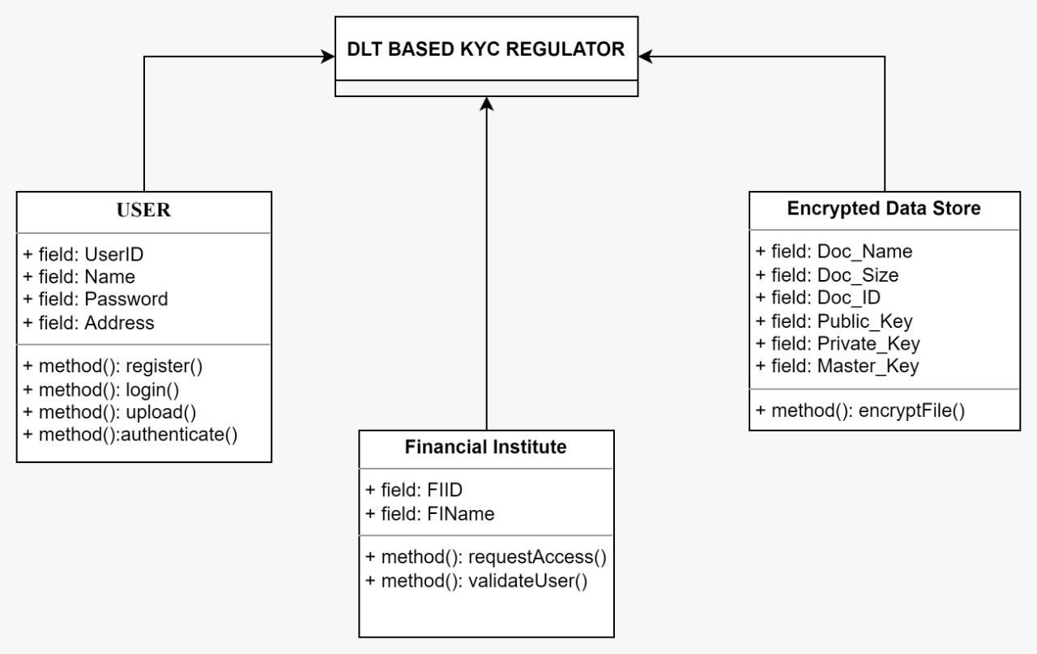

#### Fig 5.5.1 Advanced Class Design

### 5.5.2 ADVANCED STATE DESIGN

A state diagram is a graph whose nodes are states and whose directed arcs are transitions between states. It is used to represent the condition of the system or part of the system at finite instances of time. It’s a behavioral diagram and it represents the behavior using finite state transitions. State diagrams are also referred to as State machines and State-chart Diagrams. State names must be unique within the scope of state diagram. All objects in a class execute the state diagram for that class, which models their common behavior. It provides a very detailed picture of how a specific symbol changes state.

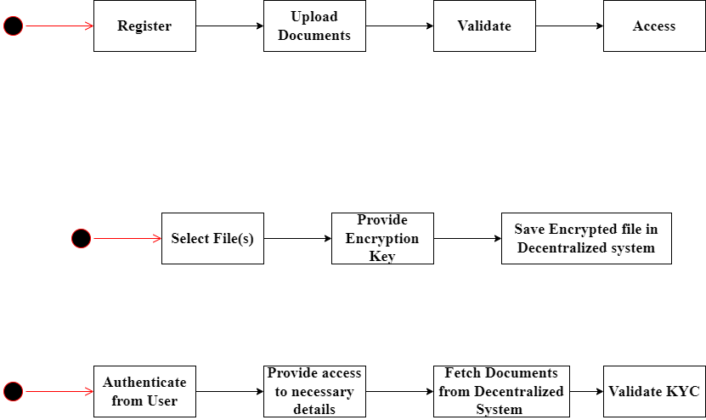

#### Fig 5.5.2 Advanced State Design for KYC Regulator

## 5.6 ADVANCED INTERACTION MODE

### 5.6.1 USER CASE MODEL

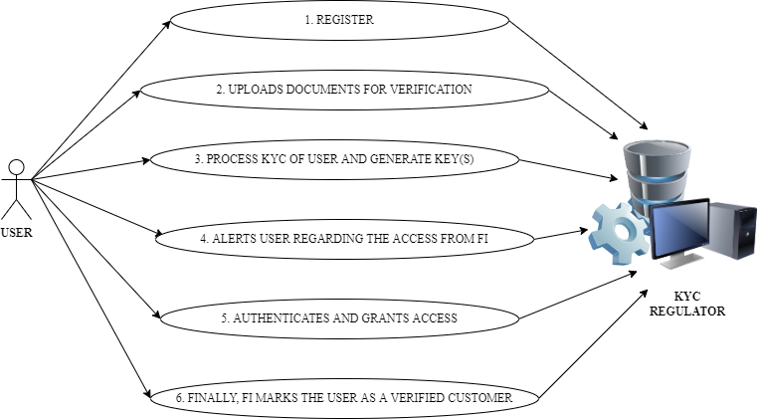

#### Fig. 5.6.1 User Case Model

### 5.6.2 SEQUENCE MODEL

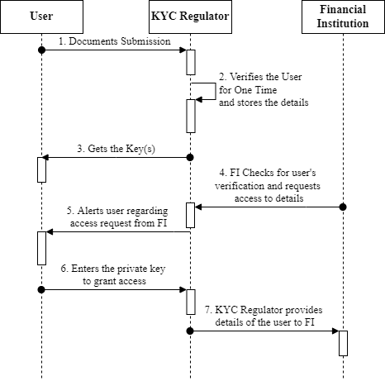

#### Fig. 5.6.2 Sequence Model

## 5.7 SWIMLANE ACTIVITY MODEL

Swimlanes are used to show which activities are performed by which organization in the activity diagram. A swimlane is a visual element used in process flow diagrams or flowcharts that visually distinguishes responsibilities for sub-processes of business process. swimlanes may be arranged either horizontally or vertically. Lines across swimlane boundaries indicate interactions among different activities.

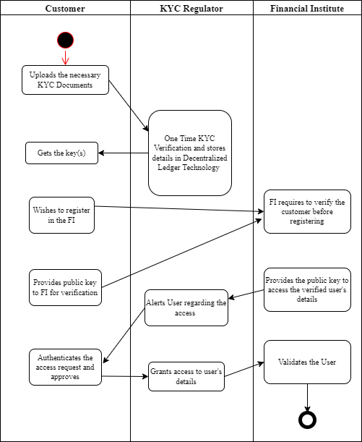

#### Fig 5.7 Swimlane Activity Model

## 5.8 USER INTERFACE DESIGN

User interface (UI) design is the process designers use to build interfaces in software or computerized devices, focusing on looks or style. Designers aim to create interfaces which users find easy to use and pleasurable. A Graphical User Interface is a user-friendly interface between the user and system. An example for User Interface that can be created for the “e-KYC Verifier using Blockchain”

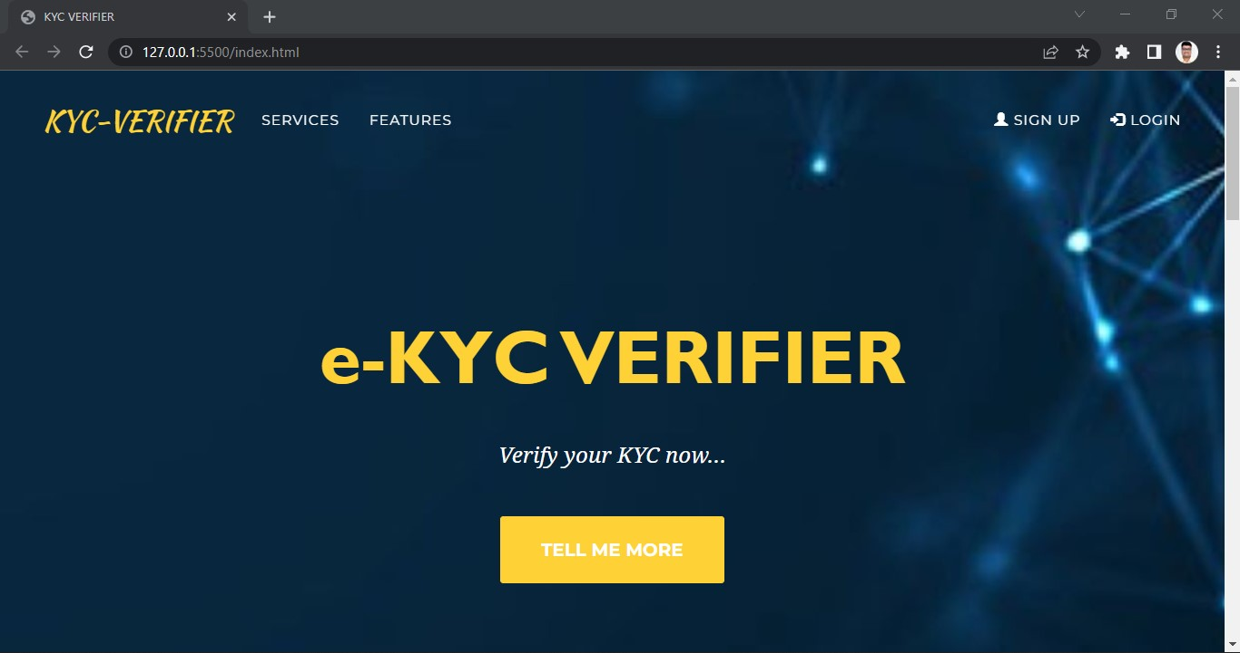

#### Fig 5.8 UI Representation of e-KYC Verifier using Blockchain

# CHAPTER 6:

# IMPLEMENTATION PHASE

## 6.1 Module – 1 : The Customer Module

**The first module**, which is the customer module, must submit the documents and details to join the network and accept or reject the permissions when his/her documents are requested for.

**FUNCTIONING**

* Customers are added to the network by providing their details and documents to the KYC Regulator.
* The KYC Regulator verifies the customer details and documents and adds the customer to the network.
* Each customer and each document is given a unique id through which they can be accessed by the banks.
* For each document submitted after verification, a blockchain is created.
* After the blockchain is created, the cost of the customer is initialized to a standard value.
* This standard value remains the same for all the customers.
* It is usually the cost of performing the KYC.

## 6.2 Module – 2 : The Bank Module

**The second module**, which is the bank module, joins into the network and requests for the details and documents of the customer.

**FUNCTIONING**

* The banks once added to the network by the KYC Regulator, it is given a unique id and a separate user page for login.
* The bank user can request for a customer’s documents by filling out the request form using the customer’s id and the document id.

## 6.3 Module – 3 : The KYC Regulator Module

**The third module**, the regulator, the main functionality of the proposed system lies with the KYC Regulator.

**FUNCTIONING**

* The KYC Regulator receives the request and he sends a mail to the customer about the request received from the bank and for which details and documents.
* The customer replies to the KYC Regulator either to accept or reject the request; based on this reply the request is updated.
* If the request is rejected then no details are shared to the requesting bank.
* If the request is accepted, the documents are shared to the requesting bank.
* The KYC Regulator adds a block into the blockchain of the document that was requested and added as a transaction into the system.

## 6.4 SNAPSHOTS OF PSEUDO CODE/SOURCE CODE OF EACH IMPLEMENTED MODULE.

### 6.4.1 THE CUSTOMER MODULE PAGE

#### Fig 6.4.1.1 Customer page – i

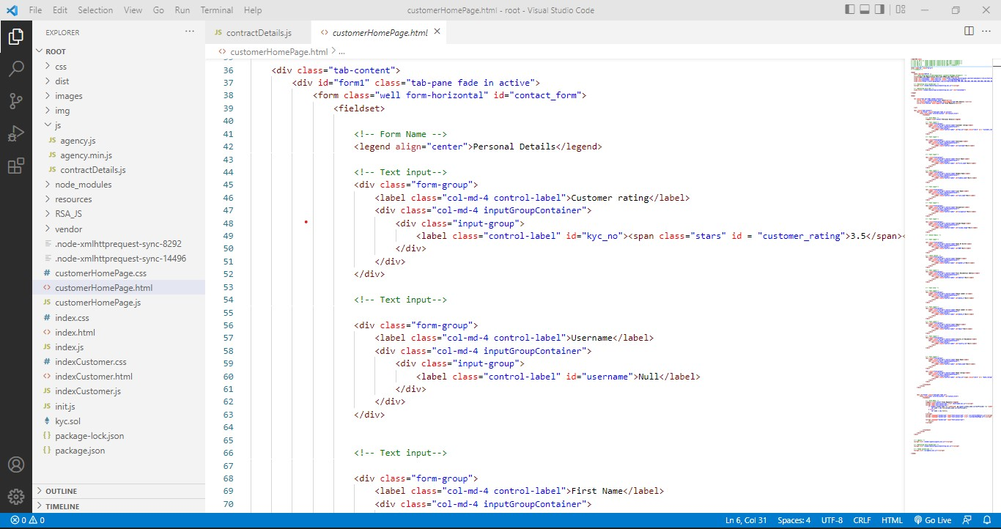

#### Fig 6.4.1.2 Customer page – ii

### 6.4.2 THE CONTRACT DETAILS

#### Fig 6.4.2 The Contract Details

### 6.4.3 THE MAIN INDEX PAGE

#### Fig 6.4.3.1 The Index Page – i

#### Fig 6.4.3.2 The Index Page - ii

#### Fig 6.4.3.3 The Index Page - iii

### 6.4.4 THE SMART CONTRACT – THE SOLIDITY CODE

#### Fig 6.4.4 The KYC Smart Contract

# CHAPTER 7:

# TESTING PHASE

## 7.1 Software Testing

Testing is the last step of completing a software system. In this phase, after getting the developed GUI and back-end combination, it is tested against the requirements stated in the requirement phase. Testing determines whether the software is actually giving the result as per the requirements addressed in the requirement phase or not. The Development team makes a test plan to start the test. This test plan includes all types of essential testing such as integration testing, unit testing, acceptance testing, and system testing. Non-functional testing is also done in this phase.

### 7.1.1 Functional Testing:

It is a type of software testing which is used to verify the functionality of the software application, whether the function is working according to the requirement specification. In functional testing, each function tested by giving the value, determining the output, and verifying the actual output with the expected value. Functional testing performed as black-box testing which is presented to confirm that the functionality of an application or system behaves as we are expecting. It is done to verify the functionality of the application. Functional testing also called as black- box testing, because it focuses on application specification rather than actual code. Tester has to test only the program rather than the system.

### 7.1.2 Non-Functional Testing:

Non-functional testing is a type of software testing to test non-functional parameters such as reliability, load test, performance and accountability of the software. The primary purpose of non-functional testing is to test the reading speed of the software system as per non-functional parameters. The parameters of non-functional testing are never tested before the functional testing. Non-functional testing is also very important as functional testing because it plays a crucial role in customer satisfaction. For example, non-functional testing would be to test how many people can work simultaneously on any software.

## 7.2 TYPES OF TESTS CARRIED OUT

* Unit testing
* Integrated testing
* Performance testing

## 7.3 SYSTEM SETUP

### 7.3.1 HARDWARE REQUIREMENTS:

**PROCESSOR**: Intel Core i3 Or Higher Configurations.

**RAM**: 8GB Or Higher.

**OS**: Windows 7 Or Higher.

**HARD DISK/SSD**: 256 GB Or Higher.

### 7.3.2 SOFTWARE REQUIREMENTS:

|  |  |  |  |
| --- | --- | --- | --- |
|  | **Name** | **Version** | **Source** |
| 1. | Solidity | V0.8.11 | https://soliditylang.org**/** |
| 2. | Remix IDE | V0.10.3 | https://remix-project.org/ |
| 3. | Python | V3.9 | https://www.python.org/downloads |
| 4. | Ganache | V7 | https://trufflesuite.com/ganache/ |
| 5. | Pinata API. | V1.0.0 | https://docs.pinata.cloud/ |

## 7.4 FUNCTIONAL TESTING

### 7.4.1 UNIT TESTING

Unit testing, a testing technique using which individual modules are tested to determine if there are any issues by the developer himself. It is concerned with functional correctness of the standalone modules. The main aim is to isolate each unit of the system to identify, analyze and fix the defects.

**UNIT TESTING TECHNIQUES**

**Black Box Testing -** Using which the user interface, input and output are tested.

**White Box Testing -** used to test each one of those functions’ behavior is tested.

**Gray Box Testing -** Used to execute tests, risks and assessment methods

## 7.5 NON-FUNCTIONAL TESTING:

### 7.5.1 PERFORMANCE TESTING:

Performance testing, a non-functional testing technique performed to determine the system parameters in terms of responsiveness and stability under various workload. Performance testing measures the quality attributes of the system, such as scalability, reliability and resource usage.

**PERFORMANCE TESTING TECHNIQUES**

* **Load testing -** It is the simplest form of testing conducted to understand the behavior of the system under a specific load. Load testing will result in measuring important business critical transactions and load on the database, application server, etc., are also monitored.
* **Stress testing -** It is performed to find the upper limit capacity of the system and also to determine how the system performs if the current load goes well above the expected maximum
* **Soak testing -** Soak Testing also known as endurance testing, is performed to determine the system parameters under continuous expected load. During soak tests the parameters such as memory utilization is monitored to detect memory leaks or other performance issues. The main aim is to discover the system's performance under sustained use.
* **Spike testing -** Spike testing is performed by increasing the number of users suddenly by a very large amount and measuring the performance of the system. The main aim is to determine whether the system will be able to sustain the workload.

## 7.6 TEST CASES:

The test cases given below are for individual modules and test the important features of the module:

|  |  |  |  |  |
| --- | --- | --- | --- | --- |
| **Test Case ID** | | **Test Case Description** | | |
| **1** | | **Create Bank Account and Register** | | |
| **Step** | **Test data** | **Expected results** | **Observed results** | **Remarks** |
| 1 | Take Bank details and Create account | Bank Account must be created and redirected to login page. | Bank Account is created Successfully and is redirected to the main page | Pass |

|  |  |  |  |  |
| --- | --- | --- | --- | --- |
| **Test Case ID** | | **Test Case Description** | | |
| **2** | | **Login using Credentials** | | |
| **Step** | **Test data** | **Expected results** | **Observed results** | **Remarks** |
| 2 | Take Bank Credentials as input. | Authenticate Bank  Details and prompt login. | Bank Credentials are verified and redirected to home page | Pass |

|  |  |  |  |  |
| --- | --- | --- | --- | --- |
| **Test Case ID** | | **Test Case Description** | | |
| **3** | | **Adding Customer Profile** | | |
| **Step** | **Test data** | **Expected results** | **Observed results** | **Remarks** |
| 3 | To add Customer profile by Bank by giving various information | Profile has to be created and added to Blockchain | Profile created and added Successfully. | Pass |

|  |  |  |  |  |
| --- | --- | --- | --- | --- |
| **Test Case ID** | | **Test Case Description** | | |
| **4** | | **Sending Request to Customer** | | |
| **Steps** | **Test data** | **Expected results** | **Observed results** | **Remarks** |
| 4 | Clicking on Send button after verifying | Details of customer should be sent to his/her profile. | Request Sent Successfully | Pass |

|  |  |  |  |  |
| --- | --- | --- | --- | --- |
| **Test Case ID** | | **Test Case Description** | | |
| **5** | | **Customer Registration in Customer Portal** | | |
| **Step** | **Test data** | **Expected results** | **Observed results** | **Remarks** |
| 5 | Customer should give the same Username as given to Bank and Register | Customer Registration to Portal | Customer Registered successfully | Pass |

|  |  |  |  |  |
| --- | --- | --- | --- | --- |
| **Test Case ID** | | **Test Case Description** | | |
| **6** | | **Display the KYC Request by the Bank in Customer Portal** | | |
| **Steps** | **Test data** | **Expected results** | **Observed results** | **Remarks** |
| 6 | Bank should send the request to customer | Display the Request i.e., Allow or Deny on Customer portal | Displayed the Request Successfully | Pass |

|  |  |  |  |  |
| --- | --- | --- | --- | --- |
| **Test Case ID** | | **Test Case Description** | | |
| **7** | | **Allow Operation in Customer Portal** | | |
| **Steps** | **Test data** | **Expected results** | **Observed results** | **Remarks** |
| 7 | When Customer Allows the Bank to View  details | Customer details Should be displayed in Bank’s Portal | Customer details are Successfully Displayed | Pass |

|  |  |  |  |  |
| --- | --- | --- | --- | --- |
| **Test Case ID** | | **Test Case Description** | | |
| **8** | | **Deny Operation** | | |
| **Steps** | **Test data** | **Expected results** | **Observed results** | **Remarks** |
| 8 | When Customer Denies the Bank to View details | Customer details shouldn’t be displayed in Bank’s Portal with Popup message | Customer details are Successfully Displayed | Pass |

|  |  |  |  |  |
| --- | --- | --- | --- | --- |
| **Test Case ID** | | **Test Case Description** | | |
| **9** | | **Update/Modify KYC details** | | |
| **Steps** | **Test data** | **Expected results** | **Observed results** | **Remarks** |
| 9 | Bank Sends request to Update/Modify the Customer details | Customer should receive the request from the bank and act accordingly | Customer received the request successfully in Customer Portal | Pass |

# CHAPTER 8:

# RESULT AND DISCUSSION

## 8.1 SNAPSHOTS OF IMPLEMENTED MODULES.

### 8.1.1 THE MAIN PAGE OUTPUT.

#### Fig 8.1.1.1 Main Page – i

#### Fig 8.1.1.2 The Main Page - ii

#### Fig 8.1.1.3 The Main Page - iii

#### Fig 8.1..1.4 The Main Page – iv

### 8.1.2 THE LOGIN: BANK

#### Fig 8.1.2.1 The Bank Login Page

**ADDING THE DETAILS OF CUSTOMER AT BANK SIDE**

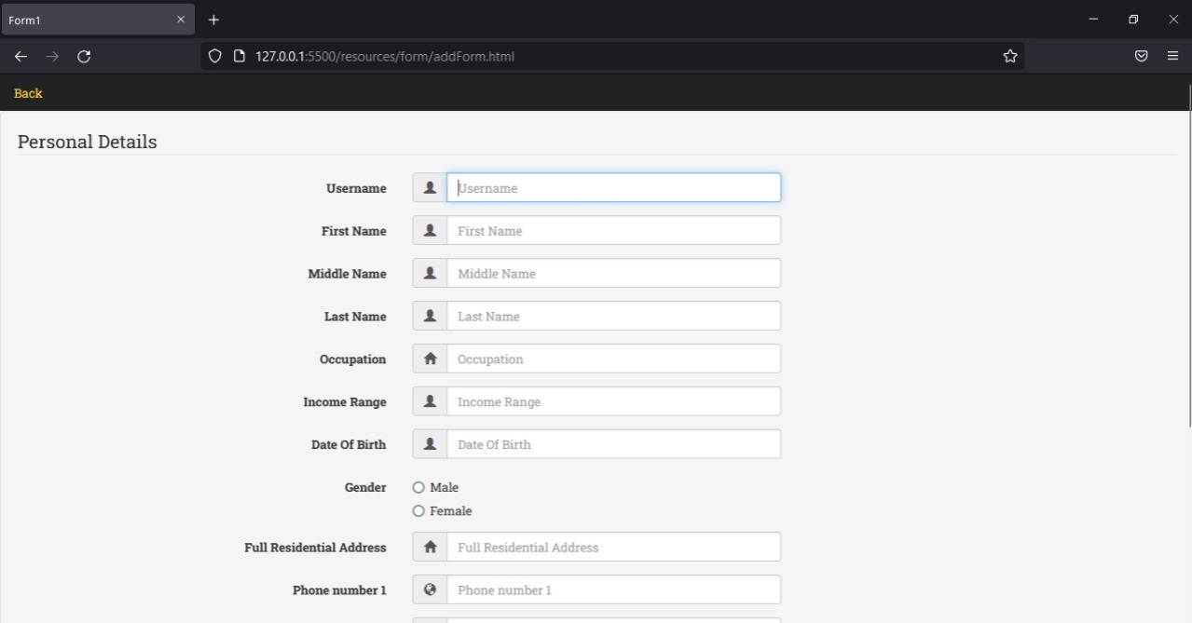

#### Fig 8.1.2.2 Adding personal details provided by the customer to bank

### 8.1.3 CUSTOMER SIGNUP, REGISTRATION AND LOGIN

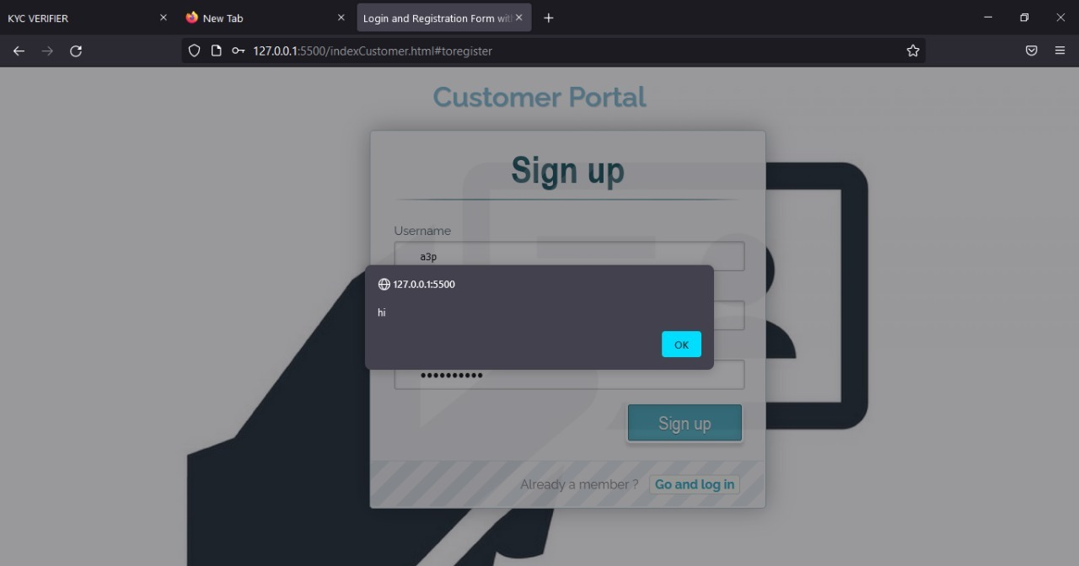

#### Fig 8.1.3.1 Customer Signup

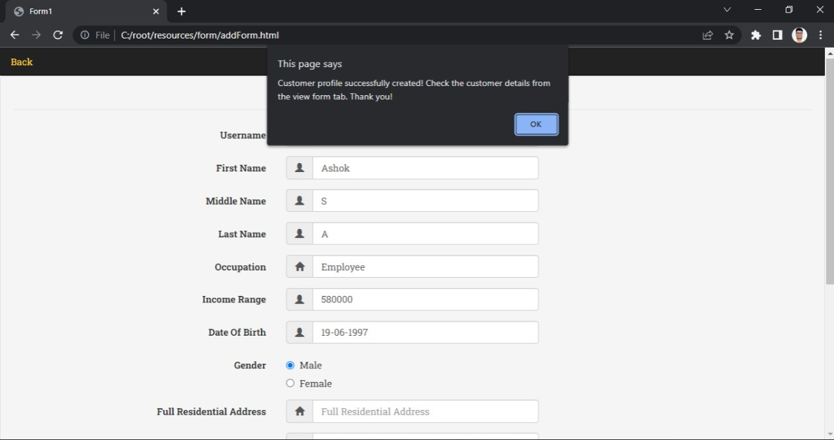

#### Fig 8.1.3.2 Customer Registration

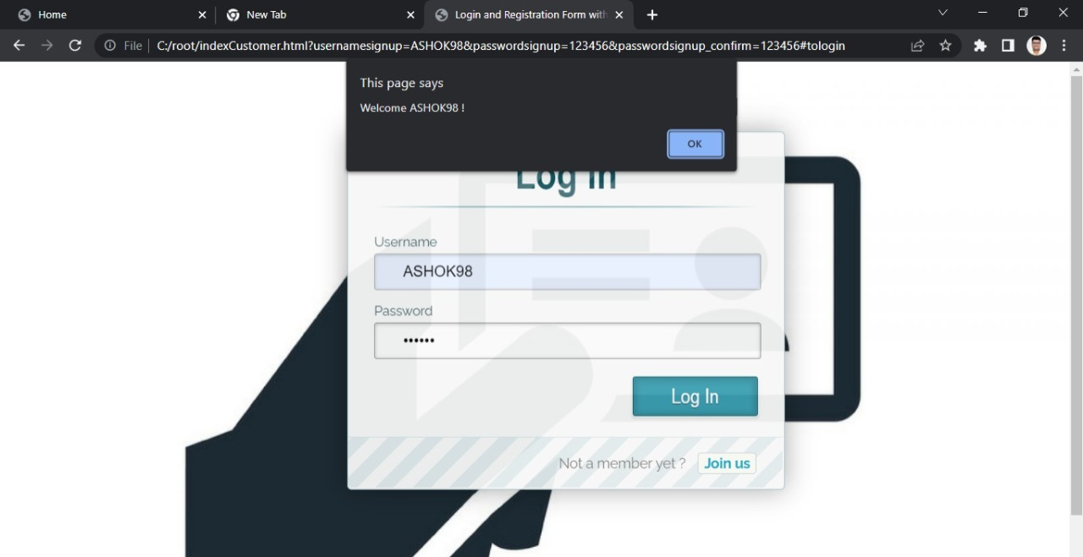

#### Fig 8.1.3.3 Customer login

### 8.1.4 BANK ACCESS TO CUSTOMER DETAILS.

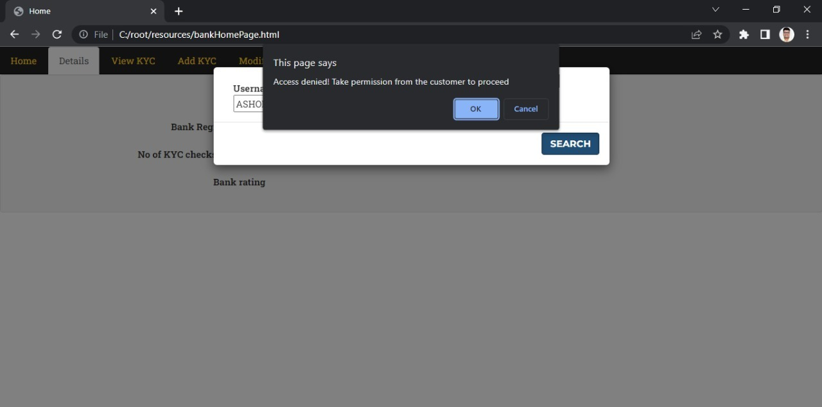

#### Fig 8.1.4.1 Access from Bank

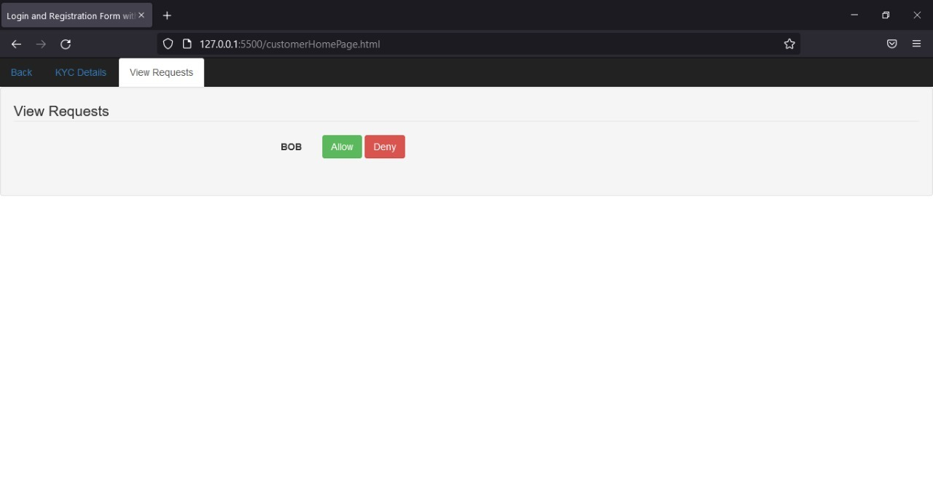

#### Fig 8.1.4.2 Request sent to customer for authentication

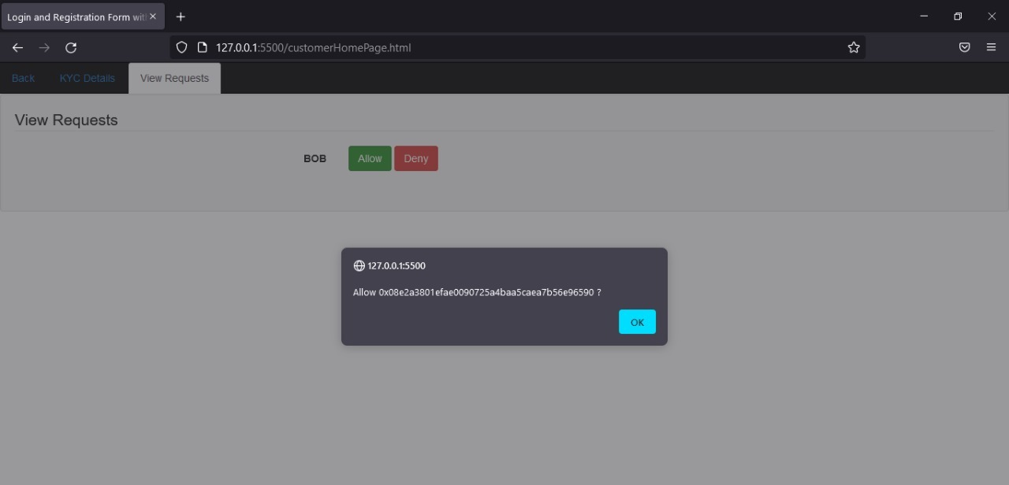

#### Fig 8.1.4.3 Confirmation from customer

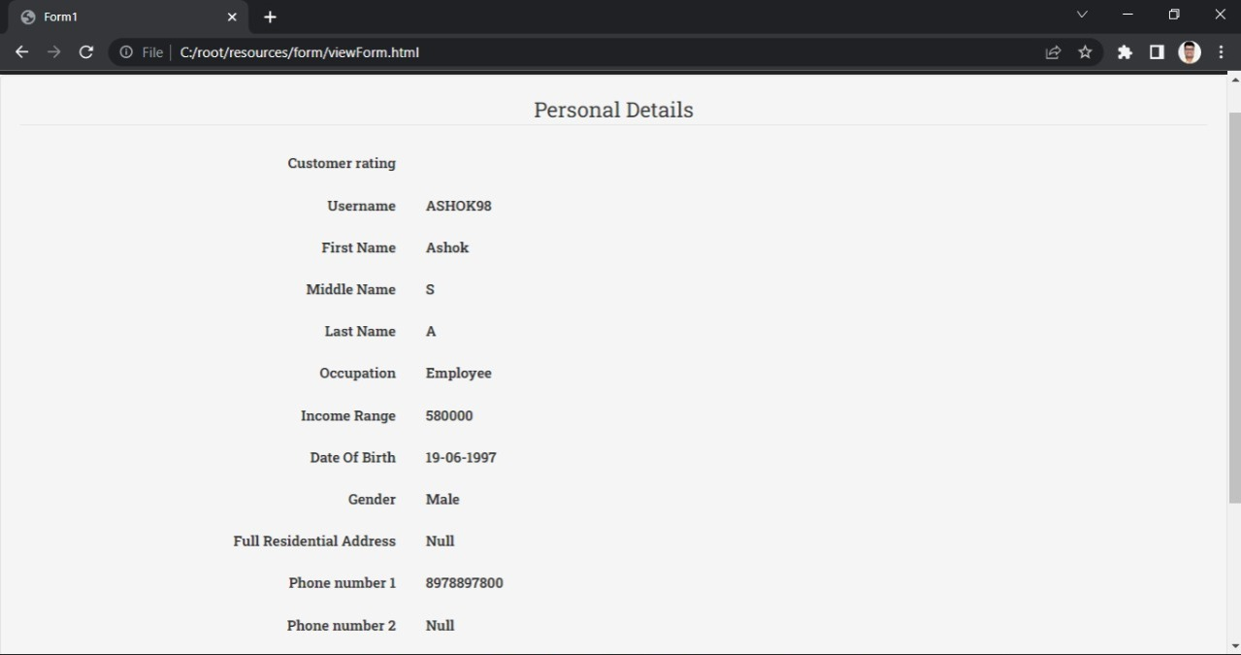

#### Fig 8.1.4.4 Customer details displayed at Bank’s end

### 8.1.5 DETAILS MODIFICATION PROCESS

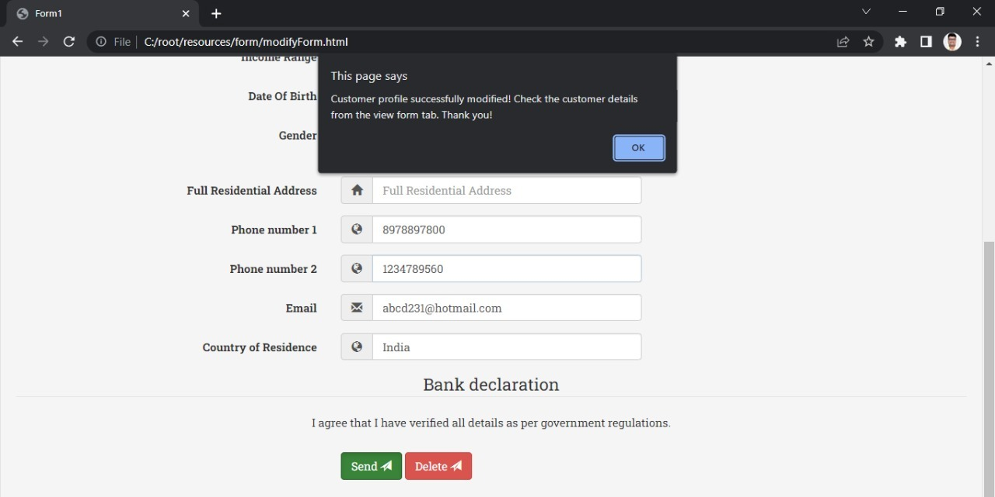

#### Fig 8.1.5.1 Customer Details Modification

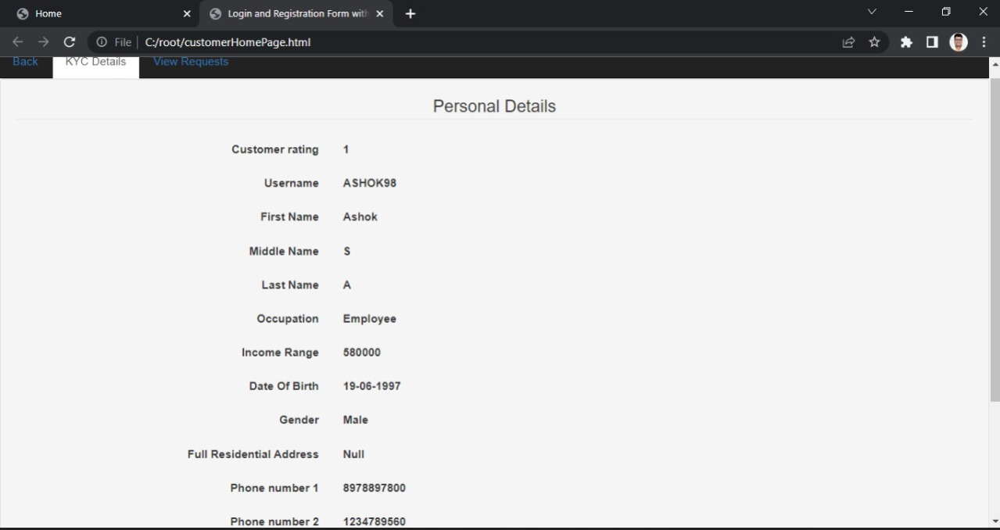

#### Fig 8.1.5.2 Successful Modification and Updated Details

* To begin, an Ethereum test network, such as ganache, is used to collect data from various account test nodes. A smart contract is implemented on the network at the same time as a blockchain address is obtained. The received blockchain address is updated in the corresponding file.
* The KYC Regulator adds the bank to the network and assigns it a unique identifier as well as a login page. By filling out the request form with the customer's id and the document id, a bank user can obtain a customer's papers (CID given by Pinata Cloud).
* The KYC Regulator receives the request and notifies the client about it, along with the facts and papers required.
* The client responds to the KYC Regulator by accepting or rejecting the request; the request is amended based on this response. If the request is denied, no information is sent to the asking bank.
* Customers join the network by submitting their information to the KYC Regulator.
* The KYC Regulator validates the customer's information before adding them to the network.
* Each consumer is given a unique id that the banks may use to access their information. A blockchain is formed for each document that is submitted once it has been verified.
* The customer's cost is initialized to a standard value when the blockchain is formed.
* For all consumers, the standard value remains the same. Typically, it is the expense of doing the KYC.

# CHAPTER 9:

# APPLICATION

The typical KYC processes are generally repetitive, time-consuming, leading to high administrative overhead costs and inconsistency.

**The KYC information, when locally stored with the bank, has the following challenges:**

• Financial institutions must spend an unwanted cost, effort, and enormous time while processing KYC verification. This process makes FI’s to concentrate less on their core business.

• As KYC information is stored locally, other organizations cannot trust and access this KYC data.

• In the client onboarding process, the client must repeatedly submit the same documents for KYC, which will lead to a painful experience for the client.

• Typical KYC depository systems cannot adapt demands of changing regulatory requirements, and sometimes they fail to provide efficient security assurance to the existing stored information/data.

This work addresses the problem of above-mentioned challenges associated with the traditional system by using **Blockchain Technology**.

* With the introduction of blockchain solutions to handle the KYC process, data will be available on a decentralized network and can, therefore, be accessed by third parties directly after permission has been given.
* This blockchain-based KYC system will offer better data security by ensuring that data access is only made after a confirmation or permission is received from the relevant authority. This will eliminate the chance of unauthorized access and subsequently give individuals greater control over their data.
* Blockchain offers a robust hurdle against fraud. Once entered, data on the blockchain ledger cannot be altered. Data stored on the blockchain is secured by cryptography and cannot be altered without agreement by more than 51% of the network.

# CHAPTER 10:

# CONCLUSION

Privacy and security issues on blockchains are important features for any industry-focused applications and play a very important role especially as they often concern information shared over media channels (such as social media), data that contain personal preferences over media items, or interactions between users. Blockchains are supposed to be used mainly as a distributed way of storing and sharing data, but the irreversibility and transparency of blockchains mean they are probably unsuitable for privacy-sensitive data (data that can reveal physical identities and disclose for instance consumer habits, privacy and proof of location etc.).

Data stored in blockchains cannot be changed, and so it is very important that specific blockchains are designed to protect users’ privacy. One approach could be to have blockchains used only to provide a timestamp for information of specific parts of workflows referring to data that are held in external data repositories. This approach of using blockchains purely as a timestamping mechanism and not as a data store has the additional benefit of being more likely to scale in the face of large amounts of data needing to be recorded.

Finally, additional encryption of data before they are pushed into the blockchain can be possible. The main problem with this approach is that if the decryption key for encrypted data is ever made public, the encrypted content is readable by anyone with that key. Regardless of the approach taken to designing blockchains, every blockchain contains transaction data and thus all privacy by design principles have to be taken into consideration before letting any transaction in the ledgers of public/private blockchain implementations.

# CHAPTER 11:

# FUTURE SCOPE

Regarding future extensions of the system, there is work in progress regarding:

* Designing an API to enable more data sources to be integrated within our architecture and support more complex procedures for gathering diverse information about specific entities.
* Additional care will be given to the automatic connection of verified machines and their capability to provide and retrieve information from our deployed smart contracts on blockchain and our overall KYC system.
* Different machine learning approaches and artificial intelligence-based tools have been proposed to help in the detection of fraud attempts and assist in the whole KYC procedure by automatically processing a large volume of data, for example for image analysis of an uploaded photo and the assessment of the originality of a document.
* The KYC process sometimes requires complex procedures such as the examination of many external sources and request of additional documents to verify the identity of a person.
* Additionally, new regulation requirements emerge and the flexibility of a KYC system to introduce new rules is of vital importance.
* In this direction, there is conscious planning to extend the current research work on smart contracts covering also such multidisciplinary aspects and complex processes.

# REFERENCES

**[1]** *Abdullah Al Mamun, M. Shamim Kaiser, et al. “Secure and Transparent KYC for Banking System Using IPFS and Blockchain Technology”, IEEE Region 10 Symposium, 2020.*

**[2]** *K. Bhaskaran et al., "Double-Blind Consent-Driven Data Sharing on Blockchain," 2018 IEEE International Conference on Cloud Engineering (IC2E), Orlando, FL, 2018, pp. 385-391.*

**[3]** *Ms. Tina P, Ms. Shravya A, Mr. Vedant Jain, Dr. Niharika Kumar, “UNIFICATION OF KYC PROCESS USING BLOCKCHAIN”, JOURNAL OF CRITICAL REVIEWS ISSN- 2394-5125 VOL 7, ISSUE 18, 2020*

**[4]** *I GustiAyuKusdiahGemeliarana, RiriFitri Sari, Evaluation Of Proof Of Work (PoW) Blockchain Security Network On Selfish Mining, International Seminar On Research Of Information Technology And Intelligent Systems,2018.*

**[5]** *Formal Analysis of a Proof-of-Stake Blockchain, Wai Yan MaungMaung Thin, Naipeng Dong, Guangdong Ba, Jin Song Dong, 23rd International Conference on Engineering of Complex Computer Systems (ICECCS),2018.*

**[6]** *Y. Luo, Y. Chen, Q. Chen and Q. Liang, "A New Election Algorithm for DPos Consensus Mechanism in Blockchain", 2018 7th International Conference on Digital Home (ICDH), Guilin, China, 2018, pp. 116-120.*

**[7].** *https://www.forbes.com/sites/forbestechcouncil/2018/07/10/know-your-customer-kyc-will-be-agreat-thing-when-itworks/#571904918dbb*

**[8]** *P. C. Mondal, R. Deb, and M. N. Huda, "Know your customer (KYC) based authentication method for financial services through the internet," 2016 19th International Conference on Computer and Information Technology (ICCIT), Dhaka, 2016, pp. 535-540.*

**[9]** *Z. Zheng, S. Xie, H. Dai, X. Chen and H. Wang, "An Overview of Blockchain Technology: Architecture, Consensus, and Future Trends," 2017 IEEE International Congress on Big Data (BigData Congress), Honolulu, HI, 2017, pp. 557-564.*

**[10]** *Du Mingxiao, Ma Xiaofeng, Zhang Zhe, Wang Xiangwei, and Chen Qijun, A Review on Consensus Algorithm of Blockchain, IEEE International Conference on Systems, Man and Cybernetics (SMC) Banff Center, Banff, Canada, October 5-8,2017.*

# PAPER PUBLISHED







# CERTIFICATES



